Hub Ignore List

**Hub Ignore List** or **Ignore List** is the module where we ignore/restrict the particular **Manufacturer / Brand** to a particular **Dc / Hub / Spoke / Beat.** This module is used to restrict multiple brands to multiple Spokes or Hub`s.   
**Note:** Initially we named it as Hub Ignore List but later as the requirements are changed we named it to Ignore List in the UI part. Don`t get confused.  
**Add New Ignore List:**This modal is to add new ignore list from the selected options, The user can add multiple records at once with the below modal.  
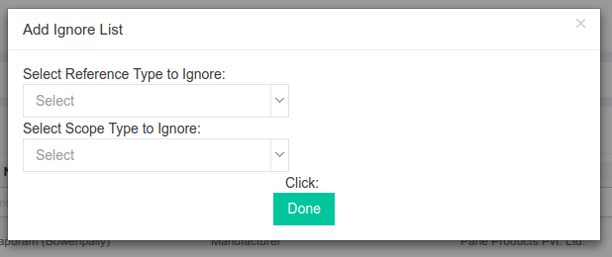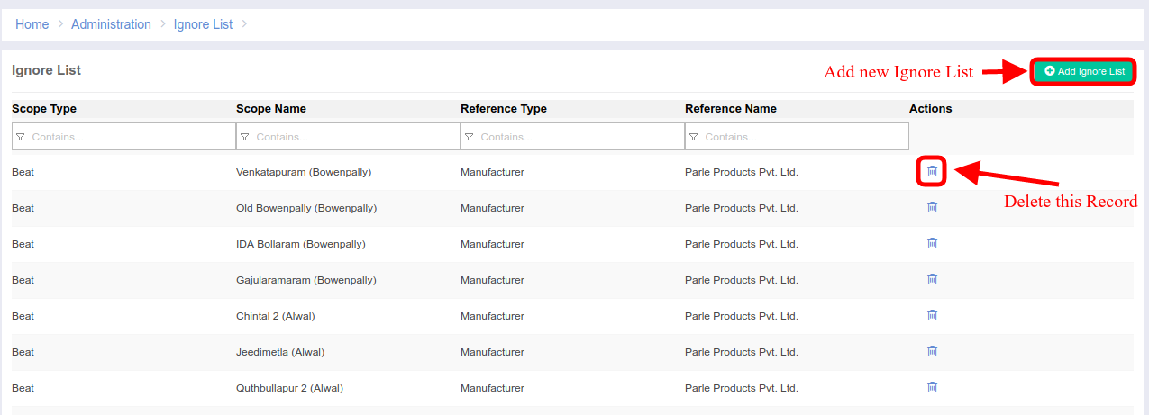

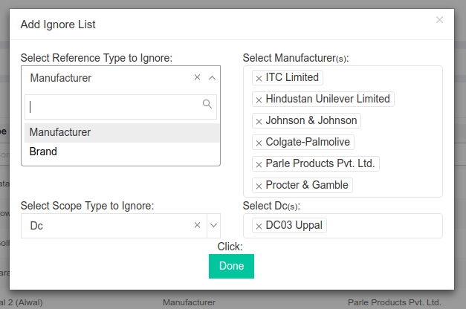

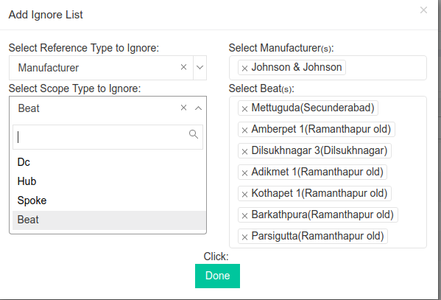  
  
Code Details:  
Module Name: **HubIgnoreList**URL: <https://portal.ebutor.com/ignorelist>  
Database: **hub_product_mapping** and other side tables like (brands, pjp_pincode_area, spokes, products, legal_entities and legalentity_warehouses) to display the information  
Feautres:  
 Add Permission [ADDHUIG01]  
 Delete Permission [DELHUIG02]